1.(1.sql) List publishers and the number of titles published by each publisher as below Use function row_number() for column [Row]. /

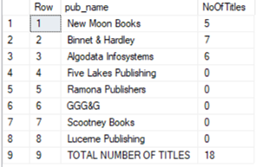

2.(2.sql) List all years and the number of titles published for each year, including the total number of titles published by all publishers as below /

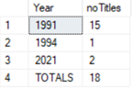

3.(3.sql) List all authors, and their number of titles, including the total number of titles at the end. Only count 1 for each title, even one title can be written by more than one author as below. Use row_number() for the column [row].

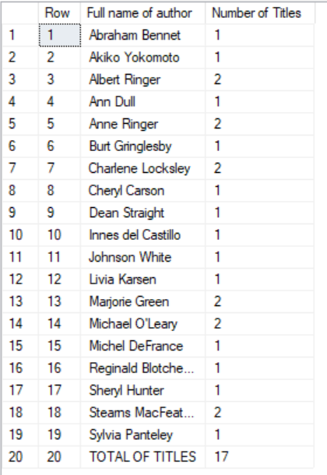

4.(4.sql) List all titles and the quantity sold for each title, including the total number sold as below. /

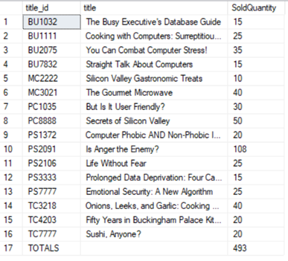

5.(5.sql) List authors that have the last character of the first name is ‘l’ as below.

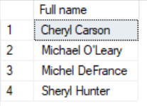

6.(6.sql) List titles that were published the most recently as below.

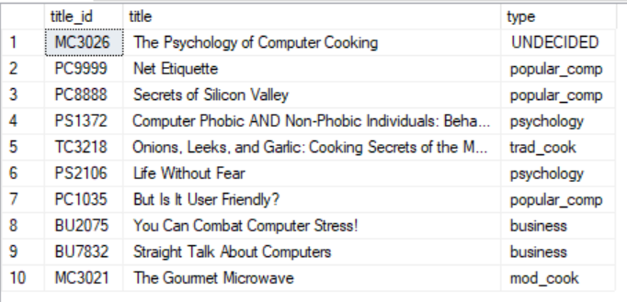

7.(7.sql) List employees that have the third character of the first name is ‘A’ as below /



8.(8.sql) List employees hired by the publisher 'New Moon Books'' from 1990 to 1993 as below.

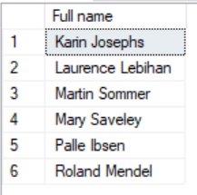

9.(9.sql) List all titles, and their sold number, including the sold total number of titles at the end. Use row_number() for the column [row].

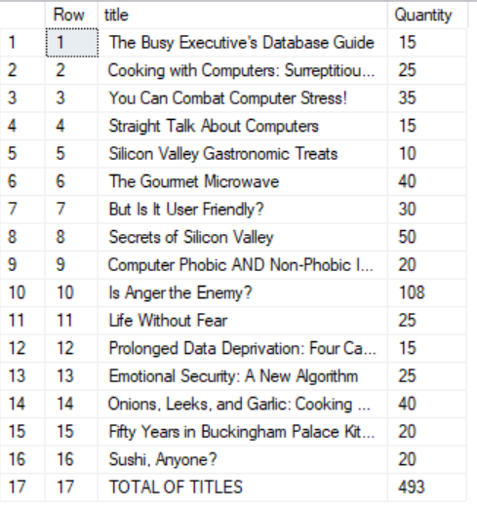

10.(10.sql) List employees that have the third character of the first name is ‘l’ as below

